For immediate release

CONTEMPORARY INDIAN ARTIST OWAIS HUSAIN
FOSTERS CREATIVITY IN THE NEXT GENERATION
THROUGH GLOBAL ARTS INITIATIVE HOUSE OF CARDS

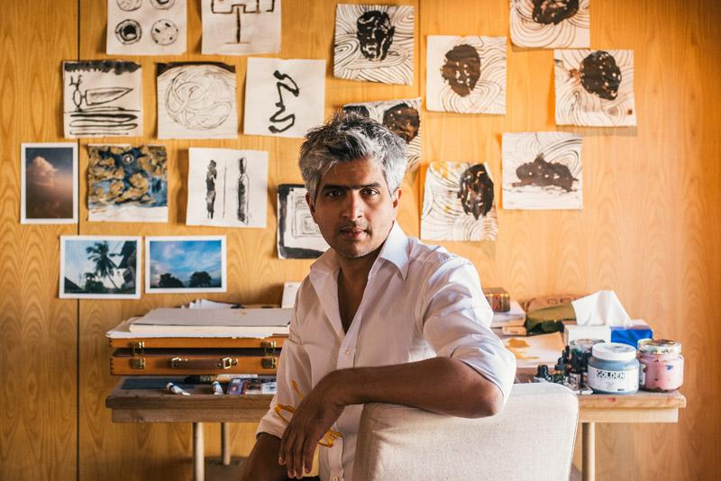
International Dubai-based artist Owais Husain, son of the late M.F Husain, presents his latest installation House of Cards at the Institute of Contemporary Arts Singapore, produced in collaboration with the students of LASALLE College of the Arts - South East Asia’s foremost arts institute.
Husain’s most recent project typifies his contemporary outlook, in which he helps the next generation to create a personal narrative, or mythology, through the practice of art. The House of Cards initiative,explores the idea of homeland and mapping identity through the continually changing landscape of visual language. In this way, Husain encourages students to think about identity and the role of image-making in all forms, inspiring them to explore in greater depth the personal context and defining influences in their work. The resulting images will be incorporated into panels designed by Husain, which form the house, creating a visual dialogue between one generation and the next.
The idea of the artist as storyteller or cartographer, charting the visual lexicons of their time the next generation is a core theme of Husain’s work. Using film, photography, painting, sculpture, installation and poetry - in various combinations or on their own - Husain creates visually textured works that both reference his roots in a traditional Indian figurative style and embody his constant pursuit to evolve and contemporise that iconography.
Following the success of the House of Cards workshop in Singapore, and in continuation of Husain’s drive to foster creativity in the next generation, he plans to roll out the initiative to selected arts colleges in key locations that also experience a confluence of cultures as a result of a history of displacement over many years. The first workshop after Singapore, will take place in India at the International Institute of Fine Arts in Modi Nagar in January 2016, with subsequent iterations planned for South Africa and Mexico.

The artistic process of the House of Cards workshops is documented and the resulting images created by the students will be exhibited alongside Husain’s own work. Proceeds from the exhibition will be reinvested in the form of a scholarship at each art school, extending the workshop’s legacy and providing further artistic opportunities for future generations.

ABOUT THE ARTIST
Husain was born in 1967 in Mumbai and graduated with his Fine Arts degree from Sir J.J School of Art in 1990. Having studied lithography and print-making at the Kanoria Centre for Arts and with apprenticeships under influential Indian artist Jagdish Swaminathan in Bhopal, and Robert Blackburn at the Printmaking Workshop in New York, Husain developed a rich mixed-media practice early into his career. While his practice is primarily based in painting, influences of Italian black and white cinema and the vibrant cinema culture of southern India led to Husain’s experimentation with film and sound in the 90s.

He has exhibited in numerous group and solo shows throughout galleries and museums in India; including the National Museum of Art and Tao Gallery, Mumbai (1995 – 2010), Vadehra Gallery, New Delhi (1995 -1998), Gallery 88 Calcutta (2000), and Sakshi Gallery Bangalore (1994); and internationally at the Tate Modern, London (2001), Aicon Gallery New York (2006), the W Foundation, Seoul (2014), and the Burj Khalifa and Capsule Arts, Dubai (2013, 2015).

In addition to this, Husain has directed and produced several feature length Hindi films, 2000-2007, and an experimental music track for the Abu Dhabi Festival of Thinkers in 2009. His films have been screened at the London International Film Festival (2000), the Berlin Film Biennale (2001), the Cannes Film Festival and Melbourne International Film Festival (2004), the Tribeca International Film Festival, Doha (2010), and the Victoria & Albert Museum, London (2014).

www.owaishusain.com

For further information on the latest news, forthcoming projects and Owais Husain’s full body of works see http://owaishusain.com/
Owais Husain is available for interview. For further information contact Naomi Davenport, Account Manager, Flint Public Relations: +91 4711 9812, naomi.davenport@flint-pr.com

About LASALLE College of the Arts

LASALLE College of the Arts in Singapore is a leading tertiary institution in cutting edge contemporary arts and design education and practice. The college offers 31 undergraduate and postgraduate programmes in fine arts, design communication, interior design, product design, film, animation, fashion, dance, music, theatre, arts management, artist education, art therapy, and Asian art histories.

Its faculty is led by a community of award-winning artists, designers, educators and researchers, and their practice-led research sets LASALLE apart as an international centre of excellence. Critically acclaimed alumni form the core of the cultural and creative sectors in Singapore and increasingly internationally.

Founded in 1984 by De La Salle Brother Joseph McNally – a visionary artist and educator – LASALLE is a not-for-profit, private educational institution. LASALLE receives tuition grant support from the Singapore Ministry of Education. Its degree programmes are validated by Goldsmiths, University of London.

About the Institute of Contemporary Arts Singapore

The Institute of Contemporary Arts (ICA) Singapore is the curatorial division of LASALLE College of the Arts, dedicated to supporting innovative and emerging creative practices. Focusing on art and design from the present, it provides an active site for contemporary culture in Singapore.

The ICA Singapore comprises five galleries that span a total of 1,500 square metres, one of the largest spaces devoted to contemporary art in Singapore. It engages local and international audiences in critical viewing and discussion through a diverse programme of exhibitions, projects, publications and events.

The ICA Singapore provides a cultural and educational tool for students and the wider public to advance their knowledge and appreciation of the contemporary local, regional and international arts.

