Vida Downtown Dubai and Owais Husain
Collaborate for Art Week Exhibition
‘Empires of Memory’
Art in Vida re-launches with an introspective and innovative video installation

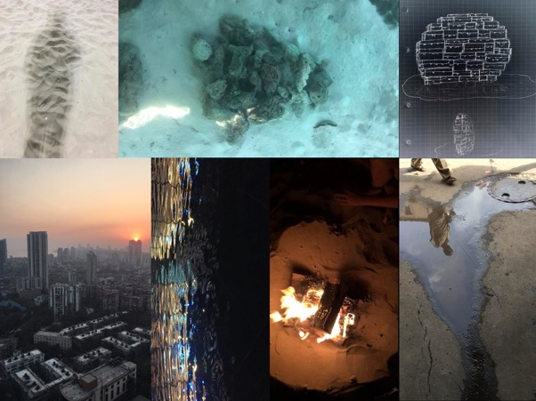

For high res images please click here:
https://www.dropbox.com/sh/wmqbfx7l361kr1u/AAAsJSTuCKRut9QaH_2R1hg2a?dl=0

After a successful year of creative collaborations, Vida Downtown Dubai has teamed up with renowned visual artist Owais Husain for the first installation of Art in Vida 2017, with his visually fascinating video installation entitled Empires of Memory. Vida Downtown Dubai is proud to continue to cement its strong support of the art and design community with the continuation of its Art in Vida program, as the boutique hotel celebrates creativity and individuality. The interactive exhibition will be on display at the boutique hotel from March 10th until April 15th with its unveiling during Art Week, as the city is bursting with creative energy.

In Empires of Memory, Owais Husain explores the themes of identity, displacement, and memory through mixed media using both video and stacked steel trunks. His exhibition explores the evolution of memory through history; how one can be used to shape, manipulate, or distort the other and how this dynamic is influenced by the hierarchies of culture through generations.

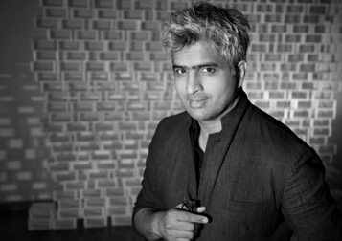

Artist, Owais Husain

The video installation combines seven steel trunks in a vertical stack, in an interactive totem pole shape, which will be sure to mesmerize guests as they dive into the artists’ mind, transported to a world of aesthetic memory seen through his abstract videos. The artist will be using film to take guests on a compelling creative journey, seen through the use of both subjective interpretations of memory on the screens of the traveling trunks.

Vida Downtown Dubai is excited to continue its creative collaborations with the artistic community, as it is proud to support emerging and established talent in the region through its Art in Vida initiative.

Exhibition Opening | Art in Vida
Empires of Memory by Owais Husain
Date: Monday, March 13th
Time: 6pm – 8pm
Location: Stage 2 Lounge, Vida Downtown Dubai

-Ends-
About the Artist:
Husain was born in 1967 in Mumbai and graduated with his Fine Arts degree from Sir J.J School of Art in 1990. His work has been featured in numerous group and solo exhibits throughout galleries and museums throughout the world, and he continues to participate in a variety of public art projects, art fairs and film festivals. Owais Husain currently lives and works in Dubai. His work explores identity, iconography and urban mythology and it’s evolution from one generation to the next, illustrating his relationship with and abstraction of a more traditional Indian aesthetic.

Website: www.owaishusain.com
Email: info@owaisstudio.com
Artist Contact: simone@owaisstudio.com
PR Contact: naomi.davenport@flint-pr.com

Vida Downtown Dubai
Located Mohammed Bin Rashid Boulevard
The Old Town, Downtown Dubai
PO Box 114788, Dubai
United Arab Emirates
For bookings: +971 4 423 8899
Email reservations@vida-hotels.com
Website: http://www.VIDA-hotels.com

For media inquiries, please contact:
Farah El Alfy | +971 55 201 5350 | farah.alfy@theqode.com
Alessandra Battalia | +971 50 312 5960 | alessandra@the-qode.com

